15/02/2025

**Workflow management system for non-crime related activity**

Software Design Document

Team 25

Contents

Introduction 2

1.1 Purpose 2

1.2 Scope 2

1.3 Reference Material 2

1.4 Definitions and Acronyms 2

Overview 3

2.1 System Overview 3

System Architecture 4

3.1 Architectural Design 4

3.2 Decomposition Description 5

Data Design 6

4.1 Data Description 6

4.2 Data Dictionary 7

4.3 Class Diagram 9

Component Design 10

5.1 Back End Component Design 10

5.2 UI Component Design 11

Human Interface Design 12

6.1 Overview of User Interface 12

6.2 UI Designs 12

Requirements Matrix 13

# Introduction

# 1.1 Purpose

This document provides a detailed design of the Workflow Management System for Non-Crime Related Activity at Yorkshire and Humber Regional Organised Crime Unit (YHROCU). It outlines the system’s architecture, components, modules and interactions to ensure the successful implementation of the system while showcasing the rationale behind the design.

# 1.2 Scope

The system is designed to improve task management, workflow tracking, and supervisorial reporting. It enables administrators, supervisors and users to manage tasks effectively and efficiently. This is achieved by allocating roles with unique levels of control creating a hierarchically structured and secure system. A user-friendly design, inclusive of neurodivergent staff, is also implemented using notifications to ensure tasks are never overlooked.

# 1.3 Reference Material

References will be provided as needed including system architecture frameworks and relevant documentation for easy understanding.

# 1.4 Definitions and Acronyms

* **YHROCU:** Yorkshire and Humber Regional Organised Crime Unit
* **WMS:** Workflow Management System
* **CSV:** Comma-Separated Value
* **PDF:** Portable Document Format
* **SQL:** Structured Query Language
* **PostgreSQL** – An open-source database management system.
* **HTML:** Hyper Text Markup Language – The standard markup language for creating web pages
* **JavaScript –** A coding language used to add dynamic interactions to web pages

# Overview

# 2.1 System Overview

**Login Page:**

* OpenAuth implementation
* Roles are tied to logins.

**User:**

* View tasks assigned to that user
* View priority of their tasks
* Add and edit comments on their tasks
* Add files to tasks
* View and change status of tasks
* Change their password
* Update their profile

**Supervisor:**

* View all tasks
* Change priority of user tasks
* Review user tasks
* Create tasks for users
* Delete comments on tasks
* All user capabilities

**Administrator:**

* Add/Remove tasks
* Add/Remove Users
* Change the role of users
* Change password of users.
* All supervisor capabilities

**Non-role dependent features:**

* Notify staff via email or popup when assigned a task
* Categorise and summarise tasks with filters (e.g., status, due date)
* Export tasks in CSV or PDF format
* Quickly find tasks via search function
* Progress logs on tasks

# System Architecture

# 3.1 Architectural Design

The diagram below is a 3 Tier Architectural Design created using Lucidchart.

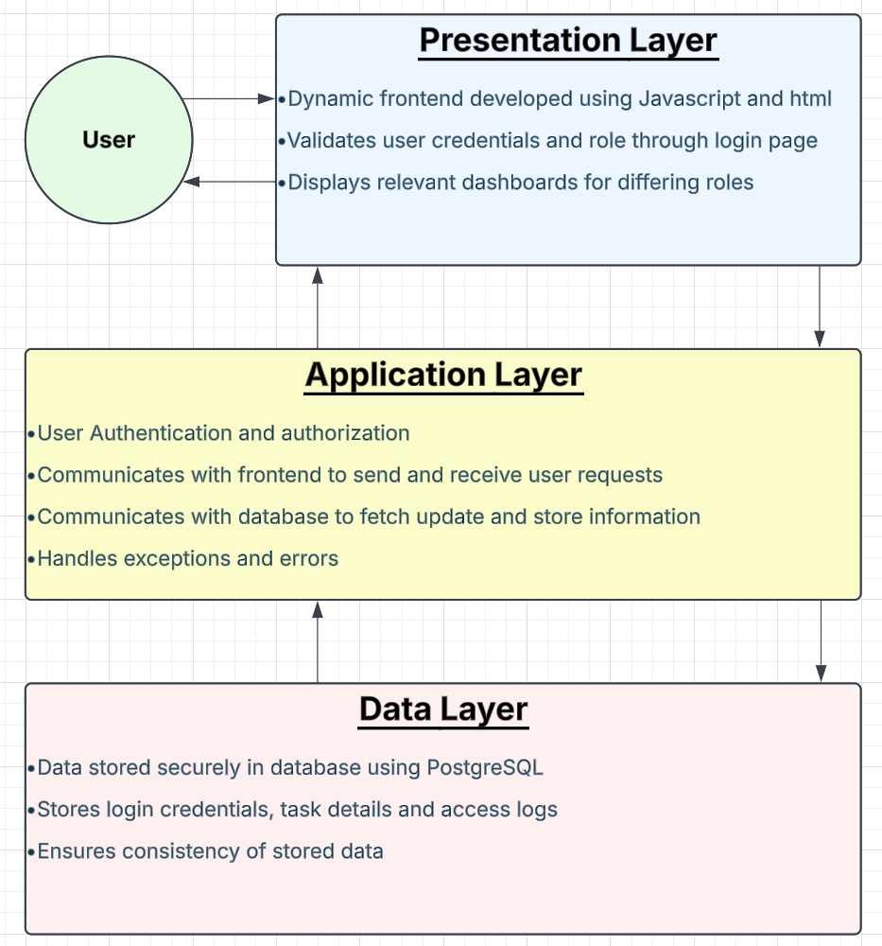

# 3.2 Decomposition Description

* **Authentication Module:** Manages user login, session handling, and role-based access
* **Task Management Module:** Handles task creation, assignment, and tracking
* **User Management Module:** Allows for creation/deletion of users, editing roles
* **User Dashboard:** Displays task lists and updates for users
* **Supervisor Dashboard:** Provides task oversight and reassignment options
* **Administrator Dashboard:** Allows for user management

# Data Design

# 4.1 Data Description

The data of the WMS is stored into structured relational tables with clear relationships. Using primary and foreign keys to maintain referential integrity, the system ensures that all stored date is structured and normalised. A diagram showcasing the entity relationships is displayed below.

# 4.2 Data Dictionary

|  |  |  |  |
| --- | --- | --- | --- |
| Entity | Attributes/Methods | Data Type | Description |
| Admin | removeTask(Task) | Method | Removes a task from the system. |
|  | addUser() | Method | Adds a new user to the system. |
|  | removeUser(User) | Method | Removes a user from the system. |
|  | changeRole(User) | Method | Changes the role of a user. |
|  | changePassword(User) | Method | Changes the password of a user. |
| Comment | commentID | String | Unique identifier for the comment. |
|  | content | String | Text content of the comment. |
|  | author | User | User who created the comment. |
|  | timestamp | Date | Date and time when the comment was created. |
|  | addComment(Comment) | Method | Adds a new comment to a task. |
| File | fileID | String | Unique identifier for the file. |
|  | fileName | String | Name of the file. |
|  | fileType | String | Type of the file (e.g., PDF, DOCX). |
|  | uploadedBy | User | User who uploaded the file. |
|  | timestamp | Date | Date and time when the file was uploaded. |
|  | addFile(File) | Method | Adds a new file to a task. |
| Supervisor | viewAllTasks() | Method | Views all tasks in the system. |
|  | changePriority(Task) | Method | Changes the priority of a task. |
|  | reviewTasks() | Method | Reviews tasks for progress and accuracy. |
|  | assignTasks(User) | Method | Assigns tasks to a specific user. |
|  | createTask() | Method | Creates a new task. |
|  | deleteComment(Comment, Task) | Method | Deletes a comment from a task. |
| Task | taskID | String | Unique identifier for the task. |
|  | title | String | Title of the task. |
|  | description | String | Brief description of the task. |
|  | priority | String | Priority level of the task. |
|  | status | int | Progress status of the task (0% to 100%). |
|  | assignedTo | User | User to whom the task is assigned. |
| User | userID | String | Unique identifier for the user. |
|  | username | String | Username used for logging in. |
|  | password | String | User's password (hashed for security). |
|  | email | String | User's email address. |
|  | role | String | Role of the user (e.g., Admin, Supervisor, User). |
|  | createdAt | Date | Date and time when the user account was created. |
|  | updatedAt | Date | Date and time when the user account was last updated. |

# 4.3 Class Diagram

# Component Design

# 5.1 Back End Component Design

**Authentication Module**

* **Functions:**
  + User login/logout
  + Session management
  + Role assignment
  + Implement OpenAuth

**Task Management Module**

* **Functions:**
  + Task assignment
  + Priority setting
  + Status tracking
  + Comment editing
  + File attaching
  + Task deletion

**User Management Module**

* **Functions:**
  + User creation
  + User deletion
  + Role changing
  + Password Resets

# 5.2 UI Component Design

**Admin Dashboard**

* **Features:**
  + Allow for admin to see all users
  + Create or delete users
  + Can see password reset requests
  + Can edit roles of all staff.

**Supervisor Dashboard**

* **Features:**
  + View all tasks and their priorities
  + Can edit comments on tasks and see statuses
  + Can see progress and activity logs for tasks
  + Can create tasks and assign them to users

**User Dashboard**

* **Features:**
  + See all tasks assigned to user ordered by priority
  + Can attach comments and files to tasks
  + Search bar and filters to search for tasks
  + Can send password reset request to admin
  + Can update their profile
  + Will have notifications when assigned a new task
  + Can export tasks to CSV or PDF format.

# Human Interface Design

# 6.1 Overview of User Interface

When the user first visits the site, they will be taken to a login page where they will be given the option to login. If the user chooses to log in the credentials will be checked to see if they match. They will then be sent to the corresponding page for their role.

If logged in as an admin, a list of all users and their info is shown. The admin will be able to delete and create users, edit their roles, and accept password reset requests. The admin can also switch to the supervisor dashboard.

If logged in as a supervisor, a list of ALL tasks will be shown including the priorities, comments, statuses and assigned users. Supervisors will also be able to create tasks to assign to users.

If logged in as a user, a list of all tasks assigned to the user is shown. Status, comments, priority and progress logs are all shown. A search bar with filters are included to help find tasks. Users can also update their profile and request for a password reset. There will also be a setting for dyslexia friendly font.

# 6.2 UI Designs

[**Concept Designs Are Stored On Github**](https://github.com/adeptcustard/Enterprise-Pro/tree/main/Concept%20Designs)

# Requirements Matrix